CS 340 README

Use this template to complete your README file. When completing the template, keep the headings as they are so that your document has a clear organization. Remove the italicized prompt text after you have completed each section for a polished final document.

About the Project/Project Title
The Grazioso Salvare Rescue Animal Dashboard uses the Austin Animal Center Outcomes dataset to help users view and filter shelter animal records in a clear and organized way. The dashboard connects to a MongoDB database through a Python CRUD module and displays the data using an interactive table, rescue filters, a breed chart, and a geolocation map. The purpose of this is to make the shelter data easier to search and understand. Instead of looking through raw database records, users can select a rescue type and quickly see animals that match the chosen criteria.

Motivation
The motivation behind this project was to create a simple and useful way for Grazioso Salvare to review animal shelter data. The company needs to find animals that may be good candidates for rescue training and looking through raw database records would take more time and could lead to mistakes. This dashboard makes the data easier to search, filter, and understand.

Getting Started
Download the project files into your local workspace or open them in codio. The MongoDB database should be running before you start the dashboard. After the files are ready, import the shelter dataset into MongoDB and confirm that the aac database and animals collection were created. Then check tha the aacuser account has access to the database. Once the database is ready, open the ProjectTwoDashboard.ipyn file and run it. The dashboard should open through JupyterDash and display the animal shelter data, filters, chart, and map.

Installation
For this project, the software and tools needed are Python, MongoDB, Jupyter Notebook, PyMongo, Pandas, Dash, JupyterDash, Dash Leaflet, and Plotly Express. Python can be installed from the official Python website. MongoDB can be installed from the official MongoDB website or used through the Codio environment. Jupyter Notebook is used to open and run the dashboard notebook. The Python libraries can be installed from the terminal. Use pip install pymongo pandas dash jupyter-dash dash-leaflet plotly

The Austin Animal Center Outcomes CSV file also needs to be imported into MongoDB before the dashboard can run. This can be done with the mongoimport command. Use mongoimport --type=csv --headerline --db aac --collection animals --drop ./aac_shelter_outcomes.csv

Usage
Use this space to show useful examples of how your project works and how it can be used. Be sure to include examples of your code, tests, and screenshots.

Code Example
@app.callback(
Output('datatable-id', 'data'),
Input('filter-type', 'value')
)
def update_dashboard(filter_type):

if filter_type == 'water':
query = {
"animal_type": "Dog",
"breed": {
"$in": [
"Labrador Retriever Mix",
"Chesapeake Bay Retriever",
"Newfoundland"
]
},
"sex_upon_outcome": "Intact Female",
"age_upon_outcome_in_weeks": {"$gte": 26, "$lte": 156}
}

elif filter_type == 'mountain':
query = {
"animal_type": "Dog",
"breed": {
"$in": [
"German Shepherd",
"Alaskan Malamute",
"Old English Sheepdog",
"Siberian Husky",
"Rottweiler"
]
},
"sex_upon_outcome": "Intact Male",
"age_upon_outcome_in_weeks": {"$gte": 26, "$lte": 156}
}

elif filter_type == 'disaster':
query = {
"animal_type": "Dog",
"breed": {
"$in": [
"Doberman Pinscher",
"German Shepherd",
"Golden Retriever",
"Bloodhound",
"Rottweiler"
]
},
"sex_upon_outcome": "Intact Male",
"age_upon_outcome_in_weeks": {"$gte": 20, "$lte": 300}
}

else:
query = {}

dff = pd.DataFrame.from_records(db.read(query))

if '_id' in dff.columns:
dff.drop(columns=['_id'], inplace=True)

return dff.to_dict('records')

Tests
The dashboard was tested by running the ProjectTwoDashboard.ipynb and checking each filter option. First, the dashboard was opened in the Reset view to confirm that the full dataset loaded into the table. Then each rescue filter was selected one at a time to make sure the table, bar chart, and map updated correctly. The Water Rescue, Mountain or Wilderness Rescue, and Disaster or Individual Tracking filters were tested. The Reset option was also tested again to make sure the dashboard returned to the original unfiltered view.

Screenshots
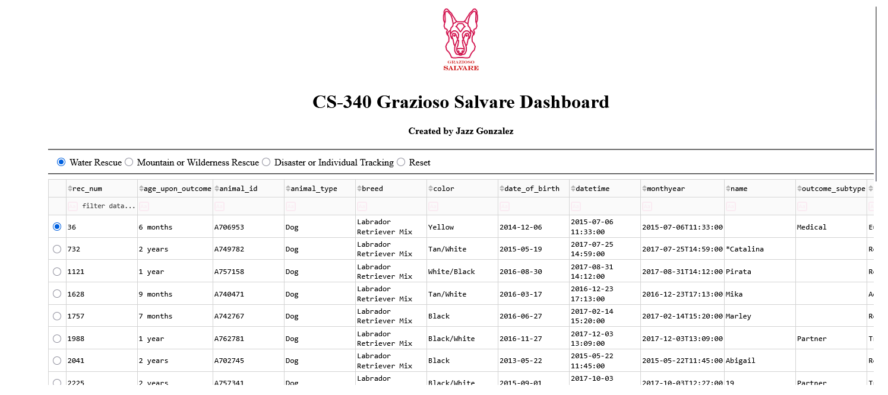

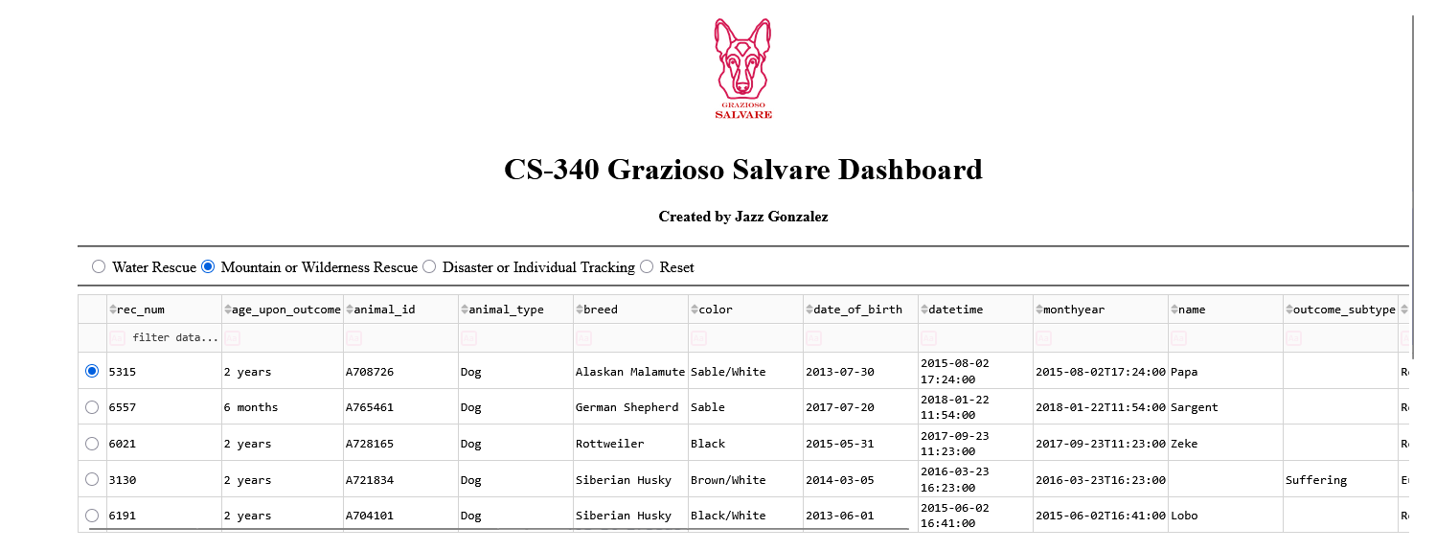
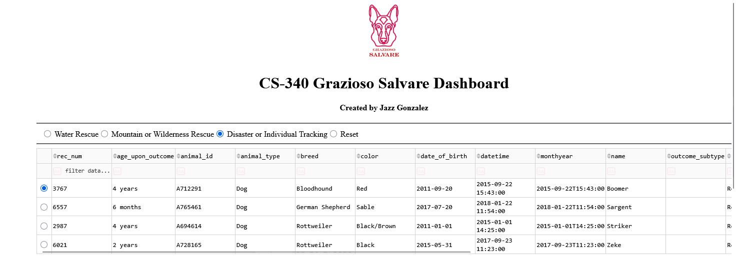
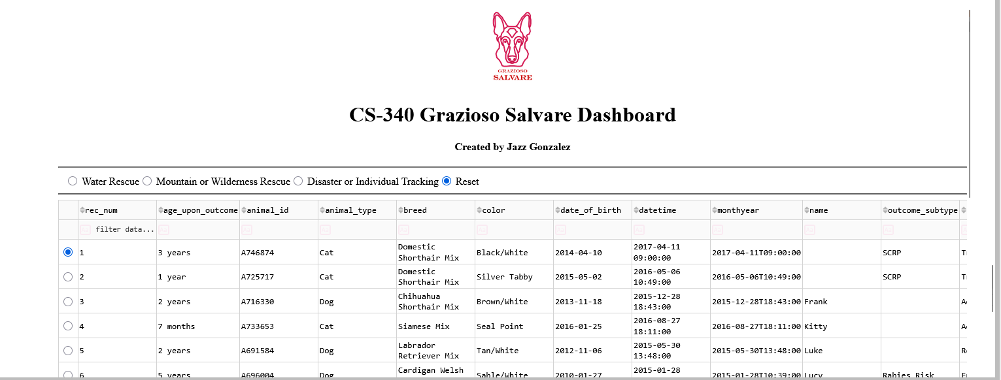

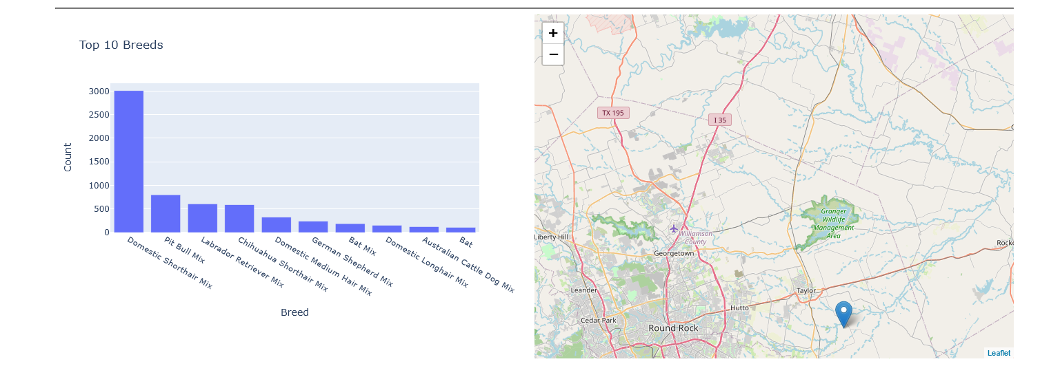

Contact
Your name: Jazzlynn Gonzalez

